**Blissful Abodes: Scalable Hotel Booking Platform With Flask On AWS EC2 And DynamoDB**

**Project Description:**

Blissful Abodes is a cloud-based hotel booking system designed to provide a seamless and scalable solution for managing hotel room reservations. Built using the Flask web framework, this application integrates core services of Amazon Web Services (AWS) such as EC2, DynamoDB, IAM, and SNS to deliver a fully functional and responsive system that caters to the needs of hotel guests, staff, and administrators.

The project was developed with the aim of automating and improving the traditional hotel booking process. It allows guests to register, browse available rooms, make bookings, and receive real-time email confirmations through AWS Simple Notification Service (SNS). The system ensures that all bookings are recorded securely in AWS DynamoDB, which acts as a fast and scalable NoSQL database. For hotel staff, the platform provides a dashboard that enables them to monitor bookings, view guest details, and update room availability as required. This improves internal coordination and ensures that availability data remains up-to-date in real time. The admin module offers complete control over the system. Administrators can view analytics such as the number of users, bookings, and rooms, as well as breakdowns by user role and room status. Admins can also manage users, delete records, and create new room entries — all through a dedicated interface that reflects the system’s backend data stored in DynamoDB.

Security and access control are managed through role-based session handling within the application and are reinforced using AWS IAM (Identity and Access Management) to define and restrict permissions for various AWS resources. The application is deployed on an Amazon EC2 instance, ensuring that it is accessible online and can scale based on traffic and demand. It is designed with keeping modularity and scalability in mind. Its use of AWS services guarantees high availability, real-time notifications, and secure data storage, making it an effective solution for modern hotel management needs.

**Scenarios:**

Scenario 1: A guest visiting the Blissful Abodes platform begins by registering with their name, email, age, password, and selecting the role “guest.” Upon registration, their data is securely stored in DynamoDB, and they are automatically subscribed to an AWS SNS topic for booking notifications, prompting them to confirm the subscription via email. After logging in, the guest can browse available rooms using filters like location, select a room, choose check-in and check-out dates, and complete a booking. This booking is saved in DynamoDB, the room status is updated to “unavailable,” and a confirmation email is sent via SNS. Guests can also view their booking history in the “My Bookings” section, which provides full details of all past and upcoming reservations, enhancing transparency and convenience.

Scenario 2: Hotel staff members log into their dedicated dashboard to manage bookings and room availability. They can view all guest reservations, filter by room ID or location, and monitor occupancy in real time. When guests check out or rooms are cleaned, staff can update room availability directly, ensuring the system reflects accurate and up-to-date data. This role supports smooth daily operations and helps prevent overbooking by maintaining live room status across the system.

Scenario 3:Admins access a central dashboard to oversee platform performance and manage users, rooms, and bookings. They can view key metrics like total user count by role, booking volume, and room availability. The admin can also add or delete users and rooms, clean up outdated or duplicate records, and review detailed booking logs for operational insights. This complete control enables the admin to ensure data integrity, platform security, and efficient system-wide coordination.

AWS ARCHITECTURE:

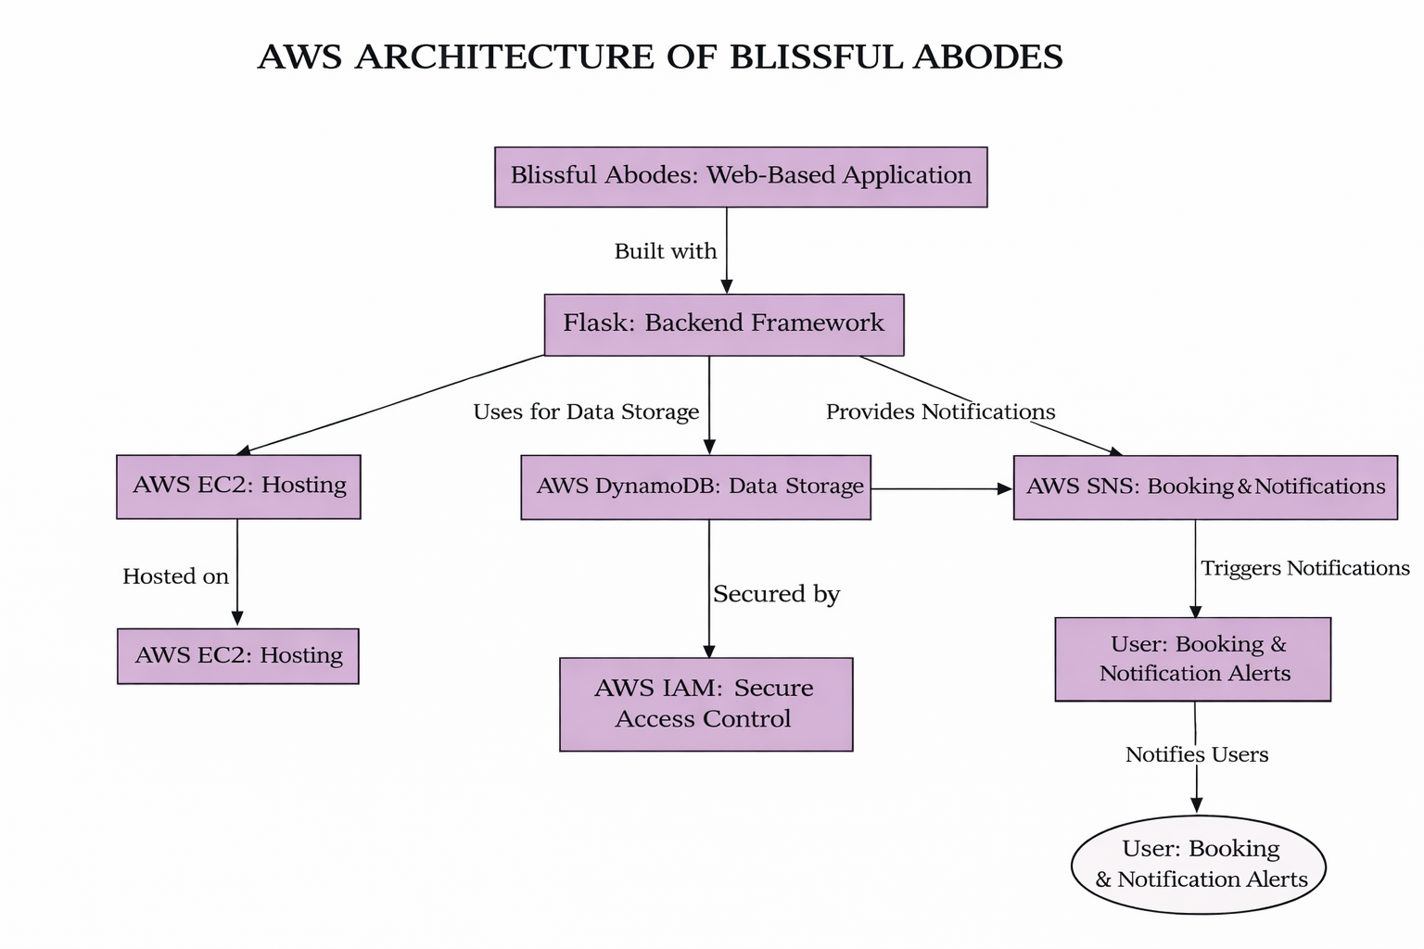

Entity Relationship (ER)Diagram:

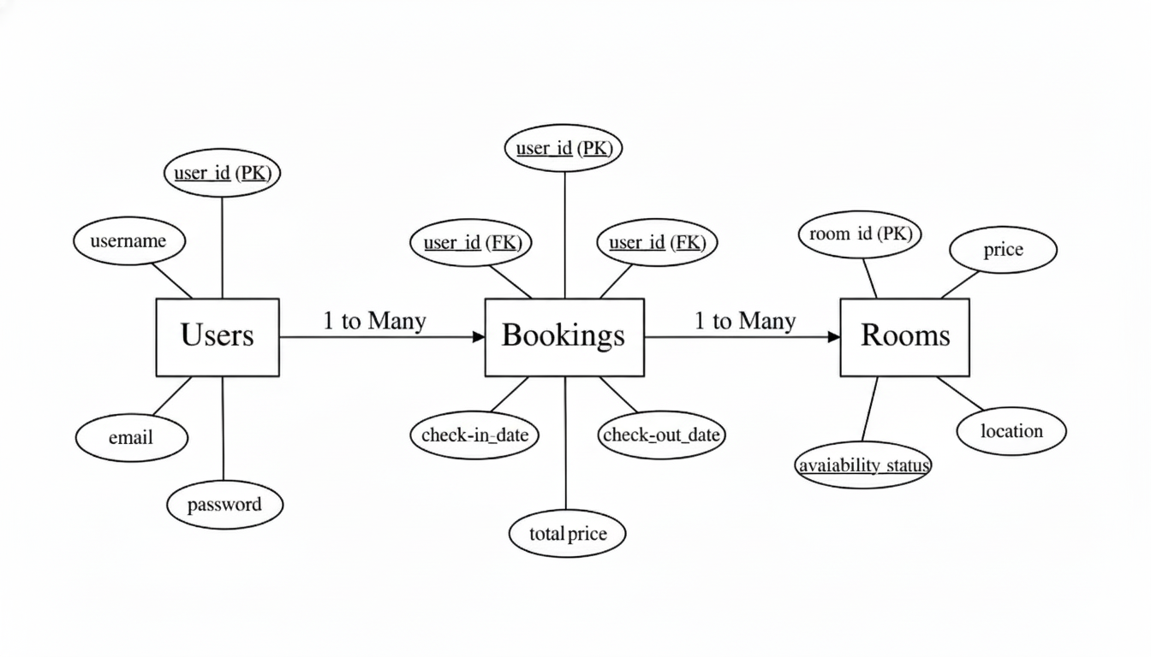

**Pre-requisites:**

**1. AWS Account Setup**: AWS Account Setup

**2. Understanding IAM**: IAM Overview

**3. Amazon EC2 Basics**: EC2 Tutorial

**4. DynamoDB Basics**: DynamoDB Introduction

**5. SNS Overview**: SNS Documentation

**6. Git Version Control**: Git Documentation

**Project Workflow:**

**1. AWS Account Setup and Login**

**Activity 1.1:** Set up an AWS account if not already done**.**

**Activity 1.2:** Log in to the AWS Management Console

**2. DynamoDB Database Creation and Setup**

**Activity 2.1**: Create a DynamoDB Table.

**Activity 2.2**: Configure Attributes for User Data and Book Requests.

**3. SNS Notification Setup**

**Activity 3.1**: Create SNS topics for book request notifications.

**Activity 3.2**: Subscribe users and library staff to SNS email notifications.

**4. Backend Development and Application Setup**

**Activity 4.1**: Develop the Backend Using Flask.

**Activity 4.2**: Integrate AWS Services Using boto3.

**5. IAM Role Setup**

**Activity 5.1**: Create IAM Role

**Activity 5.2**: Attach Policies

**6. EC2 Instance Setup**

**Activity 6.1**: Launch an EC2 instance to host the Flask application.

**Activity 6.2**: Configure security groups for HTTP, and SSH access.

**7. Deployment on EC2**

**Activity 7.1**: Upload Flask Files

**Activity 7.2**: Run the Flask App

**8. Testing and Deployment**

**Activity 8.1**: Conduct functional testing to verify user registration, login, book requests, and notifications.

**Milestone 1: AWS Account Setup and Login**

● Activity 1.1: Set up an AWS account if not already done. ○ Sign up for an AWS account and configure billing settings.



● Activity 1.2: Log in to the AWS Management Console

○ After setting up your account, log in to the AWS Management Console.



**Milestone 2: DynamoDB Creation and Setup**

● Activity 2.1: Mongo to the DynamoDB

○ In the AWS Console, navigate to DynamoDB and click on create tables.







● Activity 2.2: Create a DynamoDB table for storing Users details, room details and bookings.

○ Create Bookings table with partition key “bookingId” with type String and click on create table.

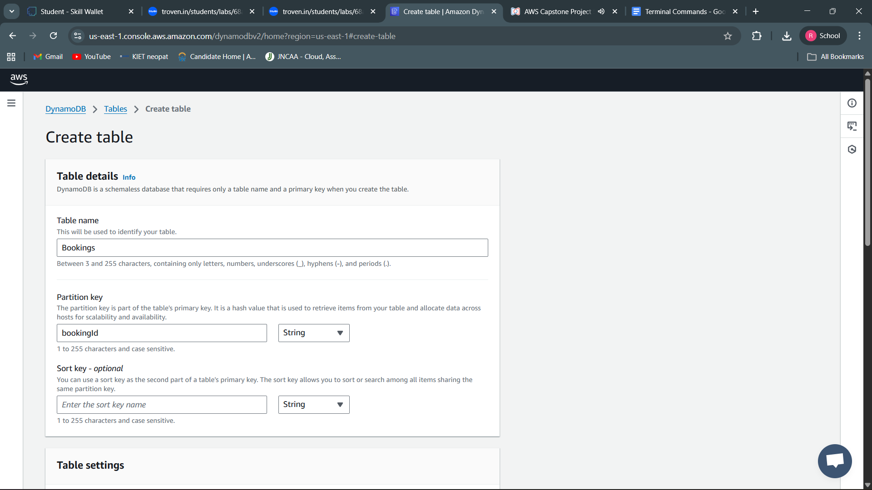

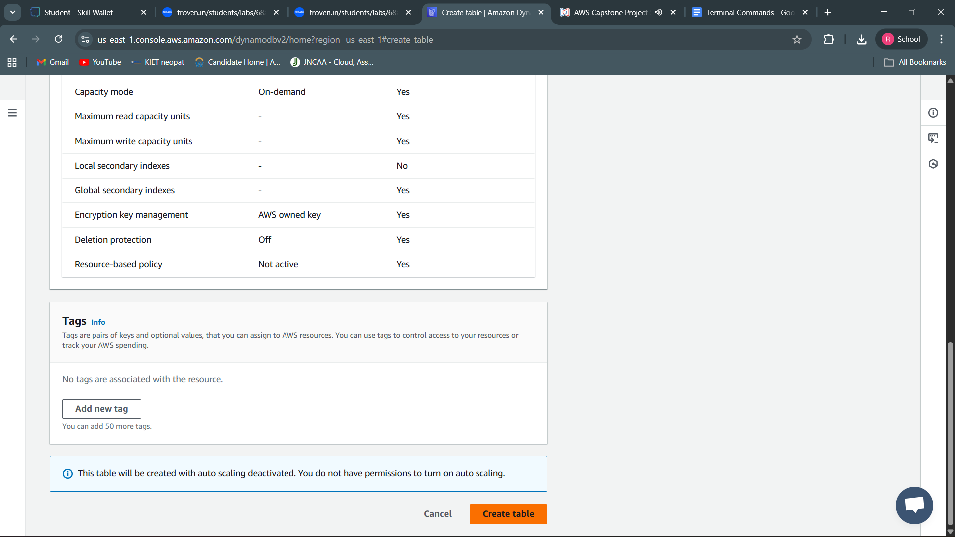

○ Follow the same steps to create Users table with userid as the primary key to store user profiles and password hashes. And Rooms with roomId as primary key to manage room inventory and prices.

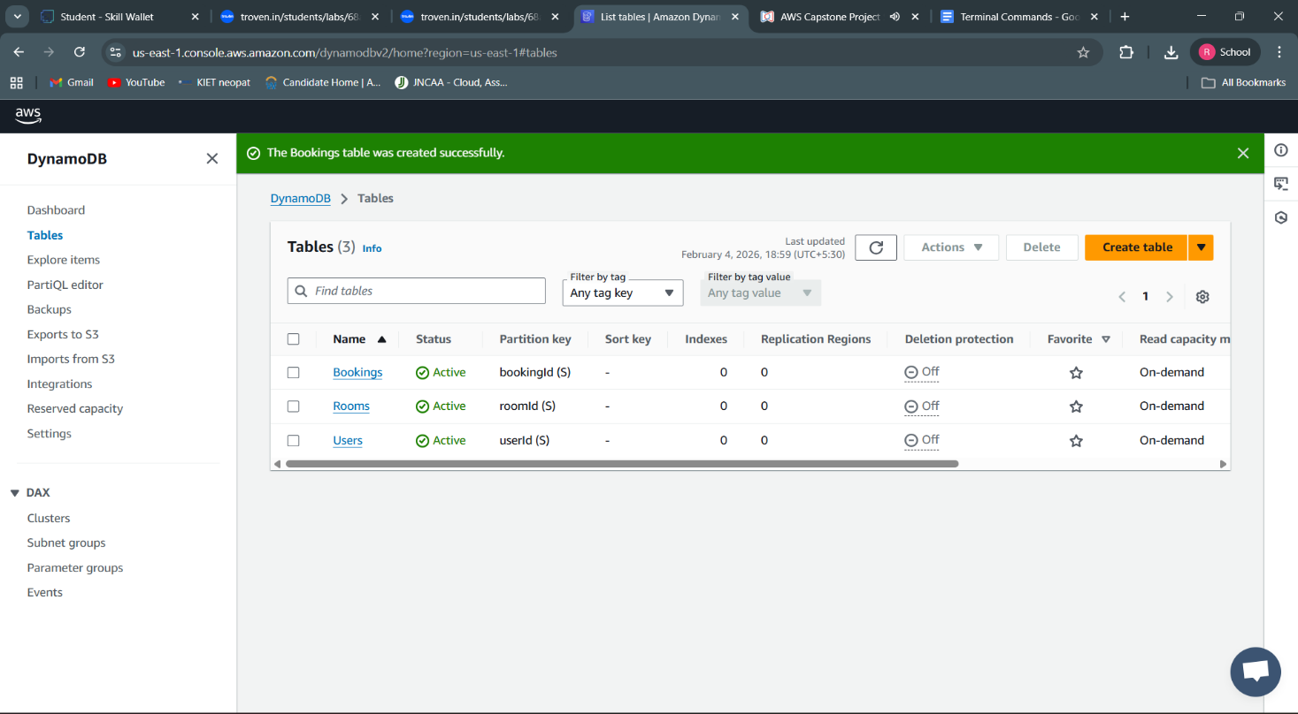

**Milestone 3: SNS Notification Setup**

**● Activity 3.1: Create SNS topics for sending email notifications to users regarding booking confirmation of their ticket.** ○ In the AWS Console, search for SNS and navigate to the SNS Dashboard.





○ Click on **Create Topic** and choose a name for the topic.



○ Choose Standard type for general notification usecases and Click on Create Topic.

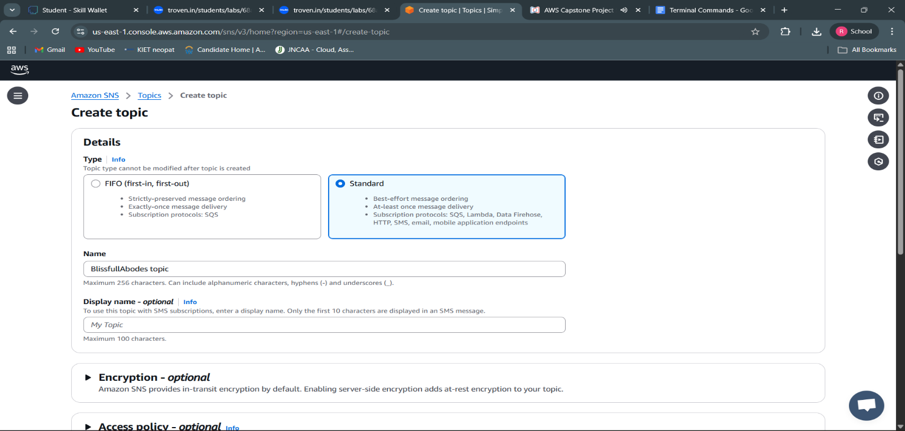



○ Configure the SNS topic and note down the **Topic ARN**.

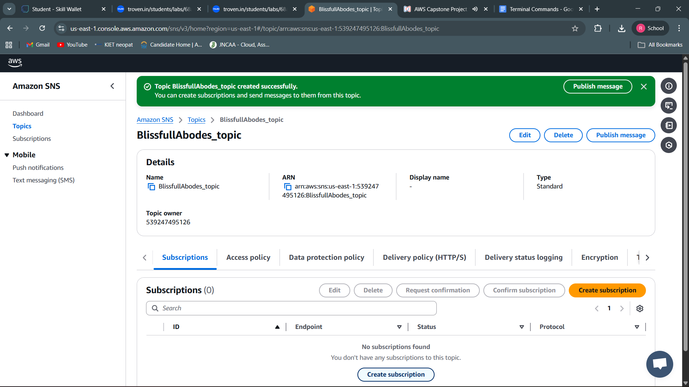

**● Activity 3.2: Subscribe users and staff to relevant SNS topics to receive real-time notifications when a booking is made.**

○ Subscribe users (or admin staff) to this topic via email. When a room is booked, notifications will be sent to the user’s emails**.**

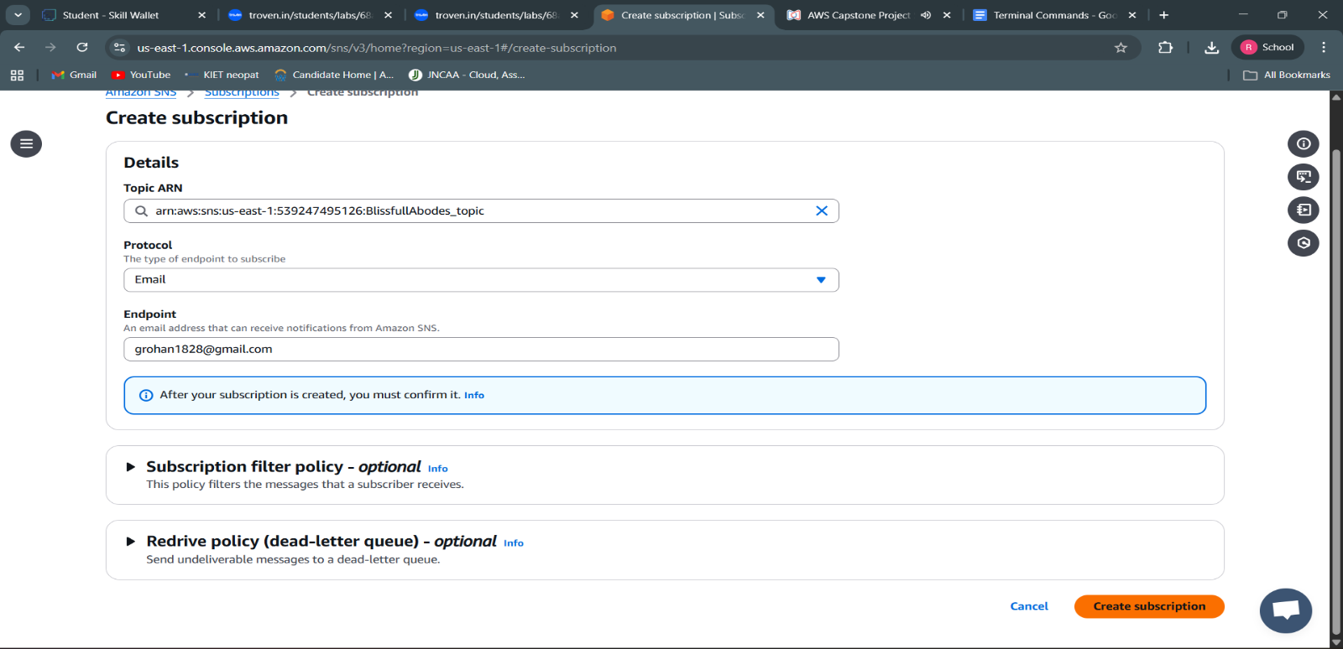

○ After subscription request for the mail confirmation

○ Navigate to the subscribed Email account and Click on the confirm subscription in the AWS Notification- Subscription Confirmation mail.



○ Successfully done with the SNS mail subscription and setup, now store the ARN link.

**Milestone 4: Backend Development and Application Setup**

● Activity 4.1: Develop the backend using Flask ○ File Explorer Structure

○ File Explorer Structure

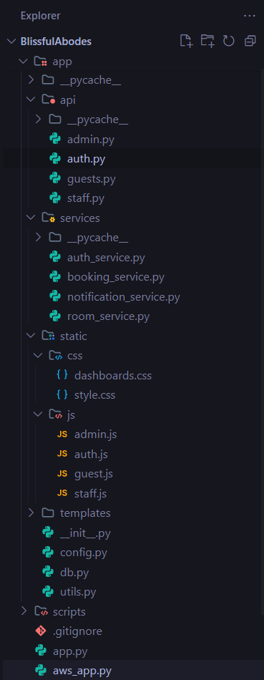

**● Flask App Initialization**

**Imports and Configuration:**



**Description**: This project uses Flask for routing, session management, and user authentication with secure password hashing. It integrates AWS services via Boto3 for handling data storage, notifications, and unique user operations.



**Description:** A new Flask application instance is initialized, and a secret key is set to securely manage user sessions and protect against cookie tampering.

**● DynamoDB and SNS Setup:**

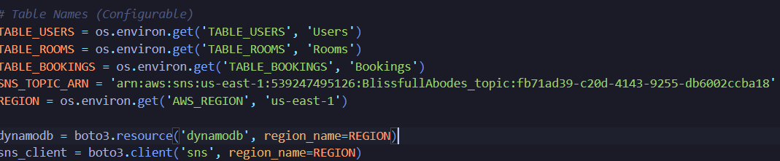

**Description**: Use **boto3** to connect to **DynamoDB** for handling user registration, movie bookings database operations and also mention region_name where DynamoDB tables are created.

**● Routes for Web Pages**

**● Admin**

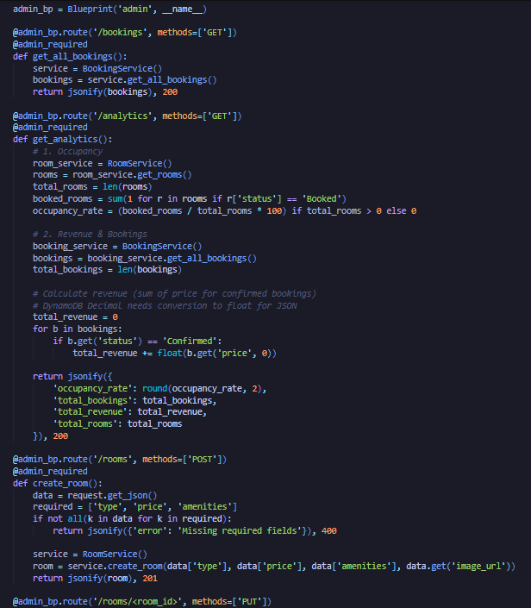

**● Guest**

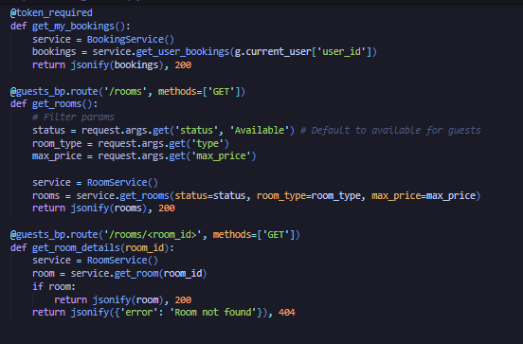

**● Staff**

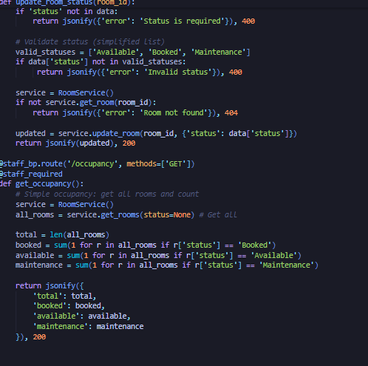

**Application Entry point:**

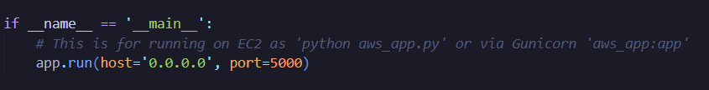

**Milestone 5: IAM Role Setup**

**● Activity 5.1: Create IAM Role.**

**○ In the AWS Console, go to IAM and create a new IAM Role for EC2 to interact with DynamoDB and SNS.**





● Activity 5.2: Attach Policies.

Attach the following policies to the role:

● AmazonDynamoDBFullAccess: Allows EC2 to perform read/write operations on DynamoDB.

● AmazonSNSFullAccess: Grants EC2 the ability to send notifications via SNS.



**Milestone 6: EC2 Instance Setup**

● **Note: Load your Flask app and Html files into GitHub repository.**

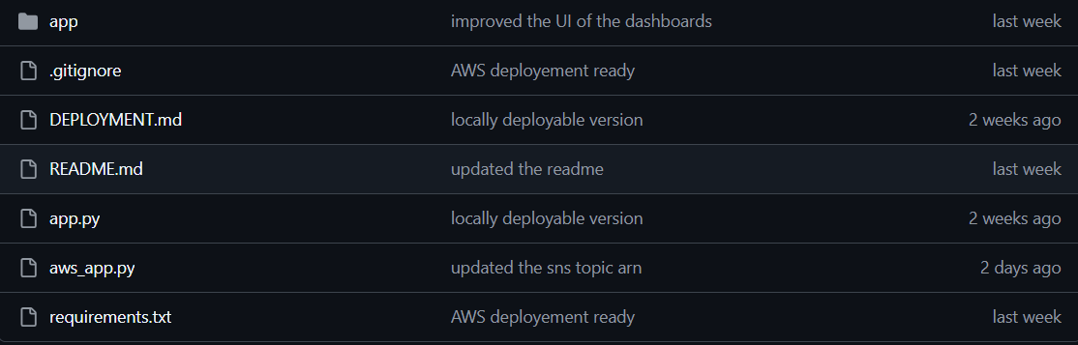

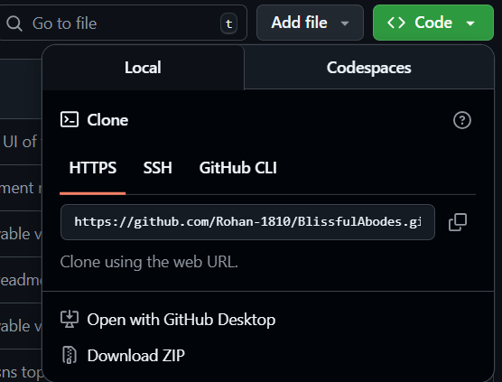

● Activity 6.1: Launch an EC2 instance to host the Flask application.

**● Launch EC2 Instance** ○ In the AWS Console, navigate to EC2 and launch a new instance.



● Click on Launch instance to launch EC2 instance

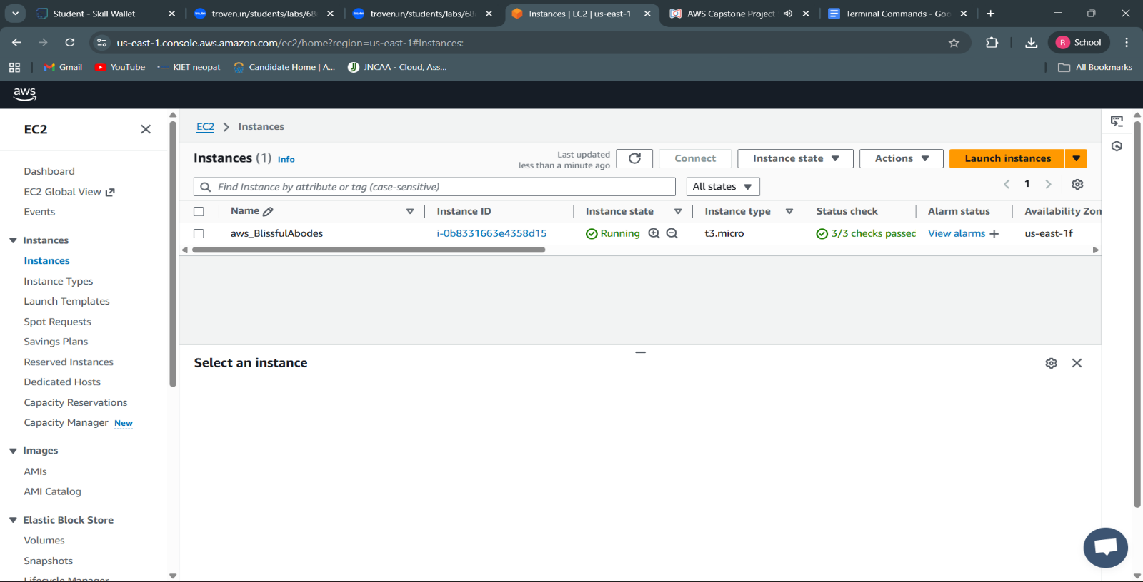

**● Activity 6.2: Configure security groups for HTTP, and SSH access.**

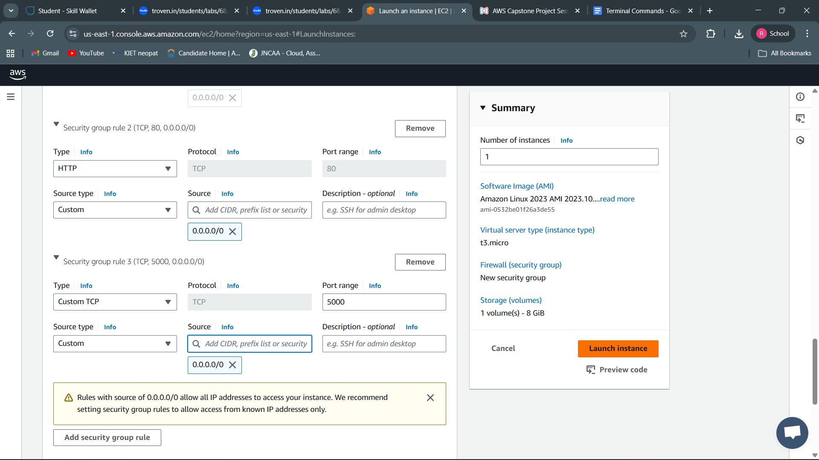

● To connect to EC2 using **EC2 Instance Connect**, start by ensuring that an **IAM role** is attached to your EC2 instance. You can do this by selecting your instance, clicking on **Actions**, then navigating to **Security** and selecting **Modify IAM Role** to attach the appropriate role. After the IAM role is connected, navigate to the **EC2** section in the **AWS Management Console**. Select the **EC2 instance** you wish to connect to. At the top of the **EC2 Dashboard**, click the **Connect** button. From the connection methods presented, choose **EC2 Instance Connect**. Finally, click **Connect** again, and a new browser-based terminal will open, allowing you to access your EC2 instance directly from your browser.

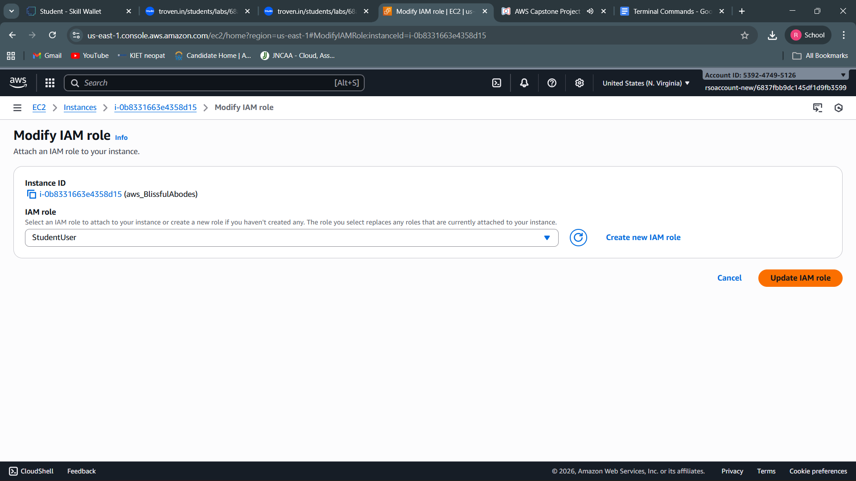

● Now connect the EC2 with the files





**Milestone 7: Deployment on EC2**

**Activity 7.1: Install Software on the EC2 Instance**

Install Python3, Flask, and Git:

On Amazon Linux 2:

sudo yum update -y

sudo yum install python3 git

sudo pip3 install flask boto3

Verify Installations:

flask --version

git --version

**Activity 7.2: Clone Your Flask Project from GitHub**

**Clone your project repository from GitHub into the EC2 instance using Git.**

**To navigate to the project directory, run the following command:**

cd BlissfulAbodes

**Once inside the project directory, configure and run the Flask application by executing the following command with elevated privileges:**

**Run the Flask Application**

sudo flask run --host=0.0.0.0 --port=5000

**Verify the Flask app is running**:

http://your-ec2-public-ip

○ Run the Flask app on the EC2 instance

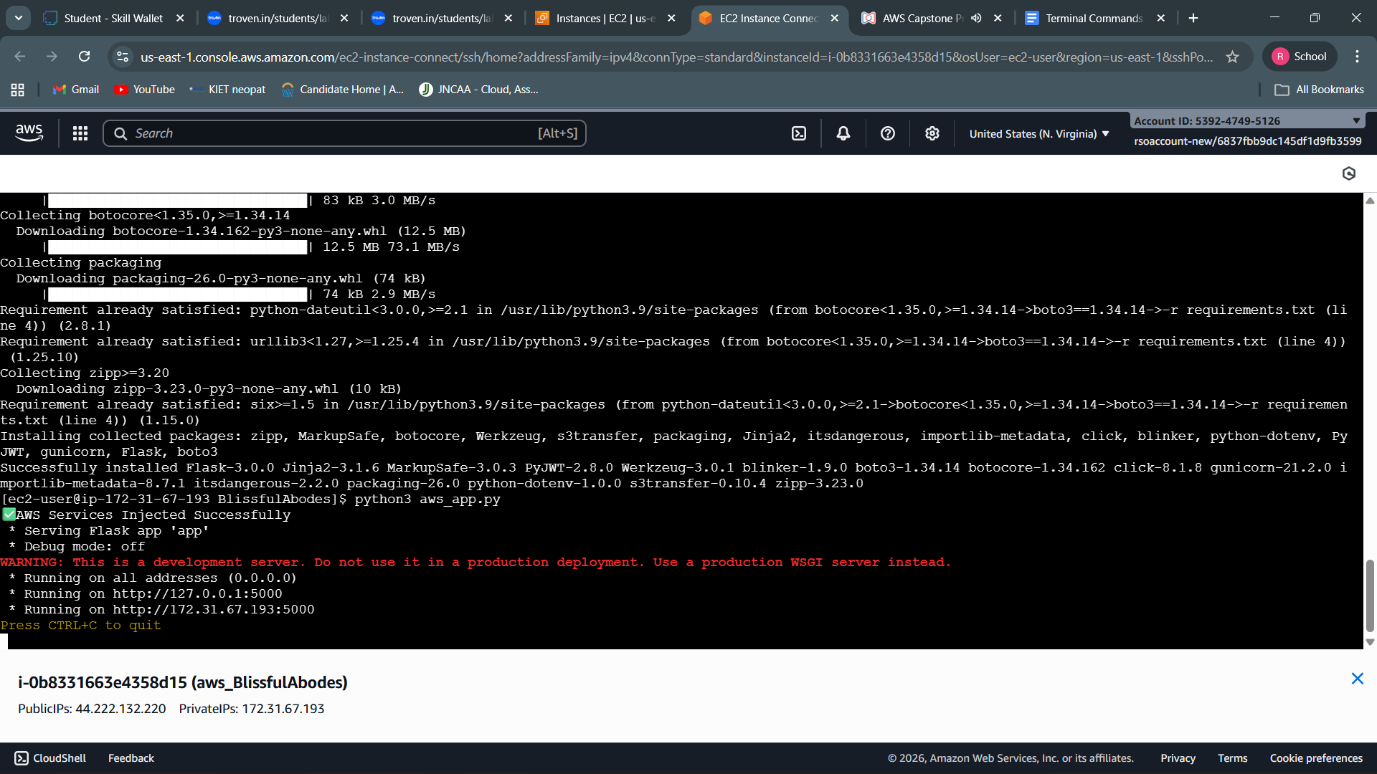

**Milestone 8: Testing and Deployment**

● Activity 8.1: Conduct functional testing to verify user registration, login, search results, Booking, and notifications.

**Home Page:**

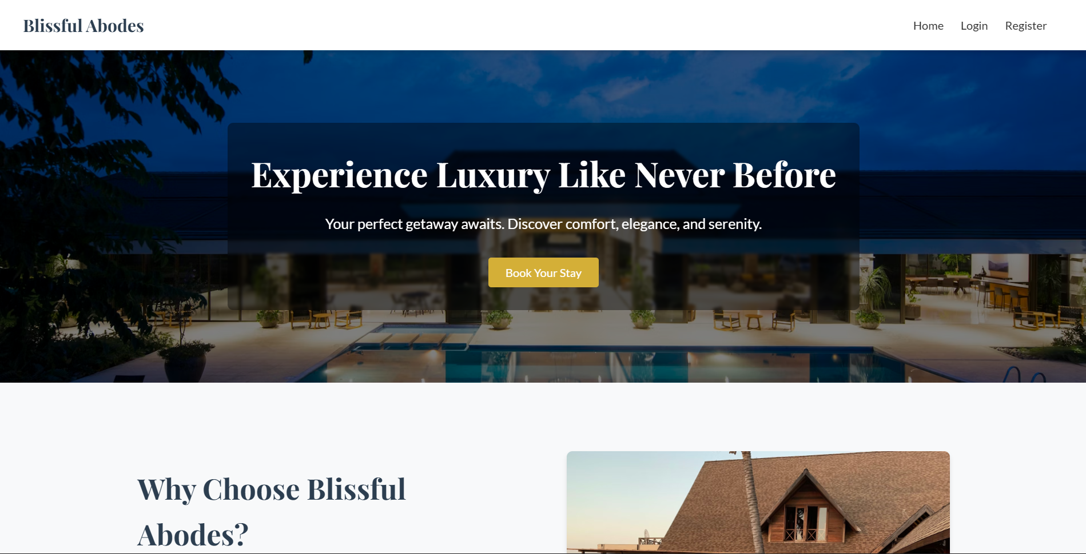

**Register Page:**

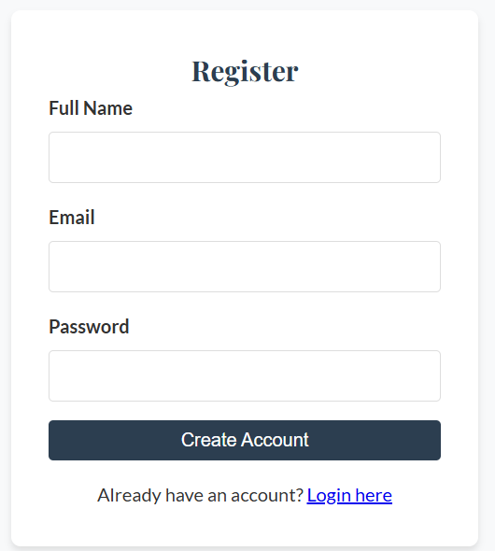

**Login Page:**

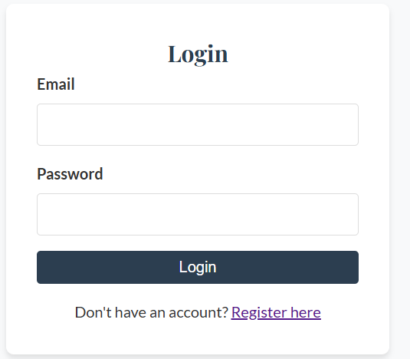

**Staff Dashboard:** 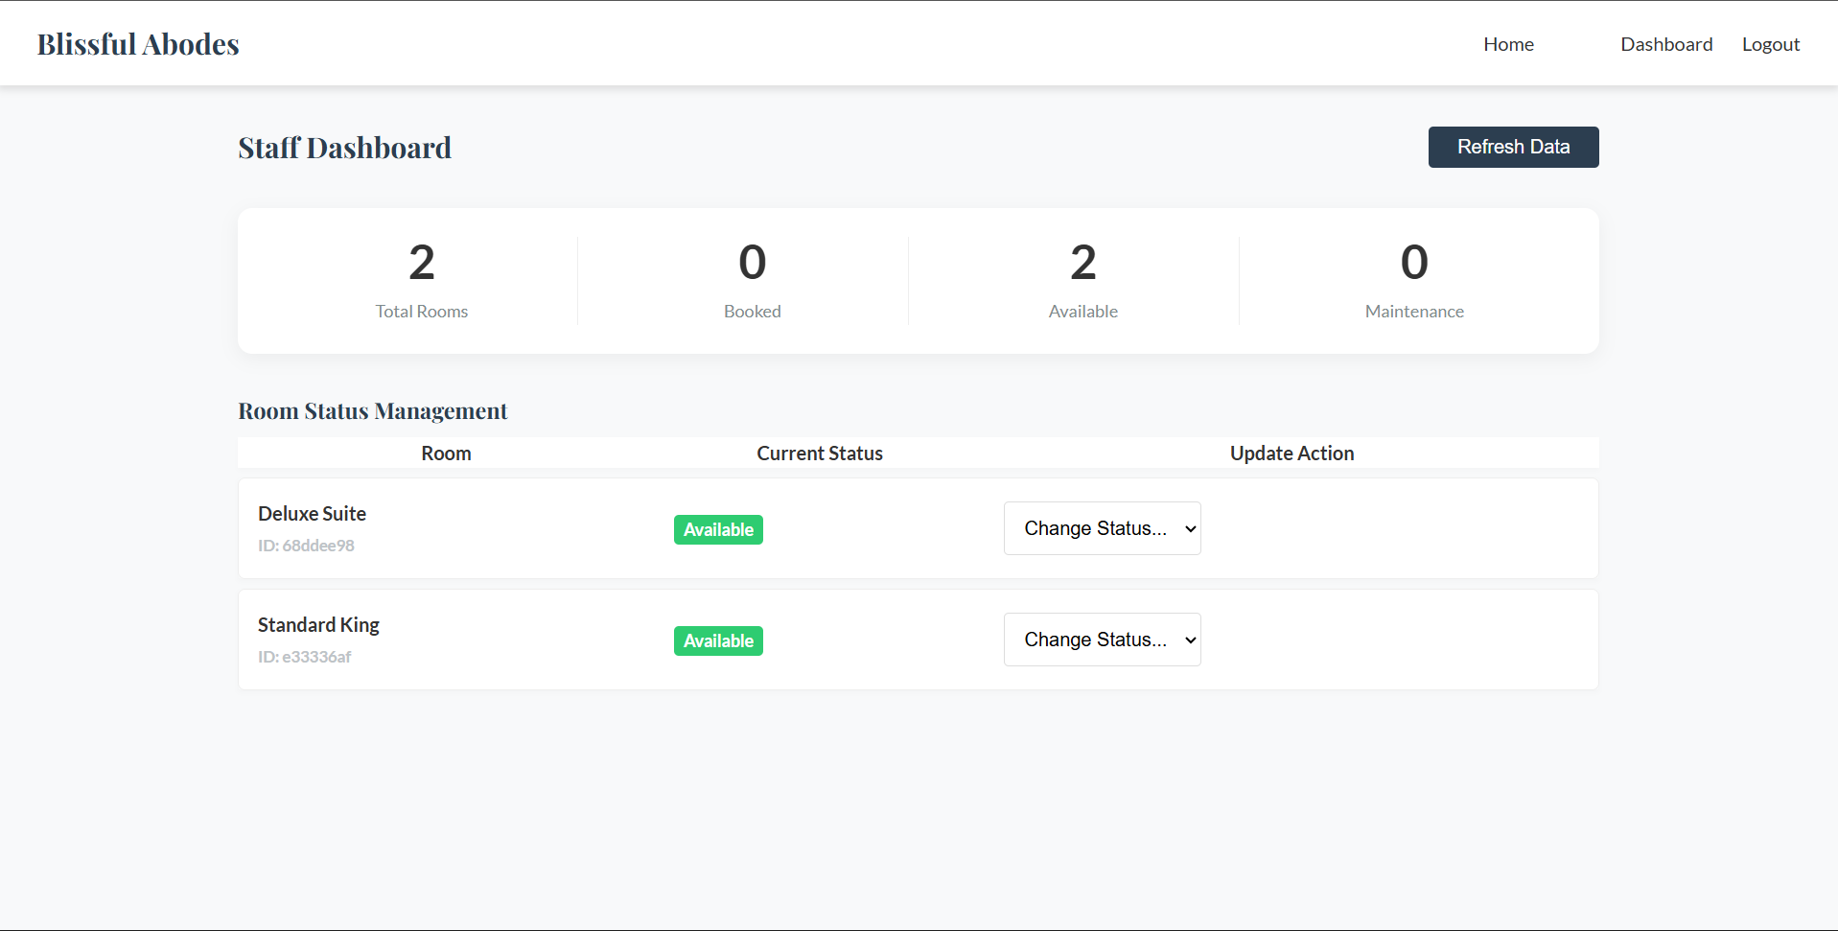

**Admin Dashboard:**

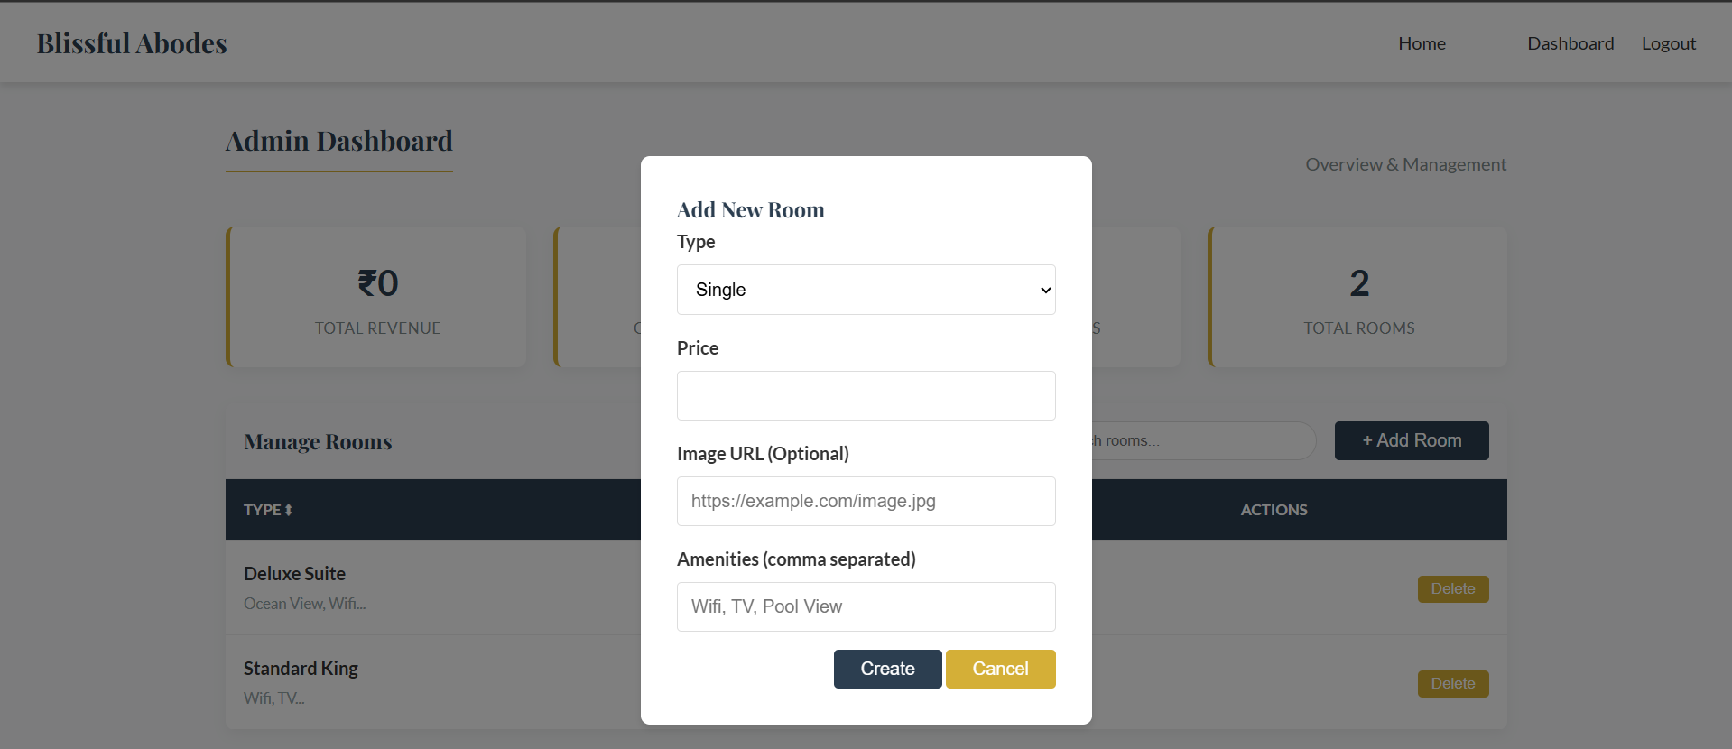

**Guest Dashboard:**

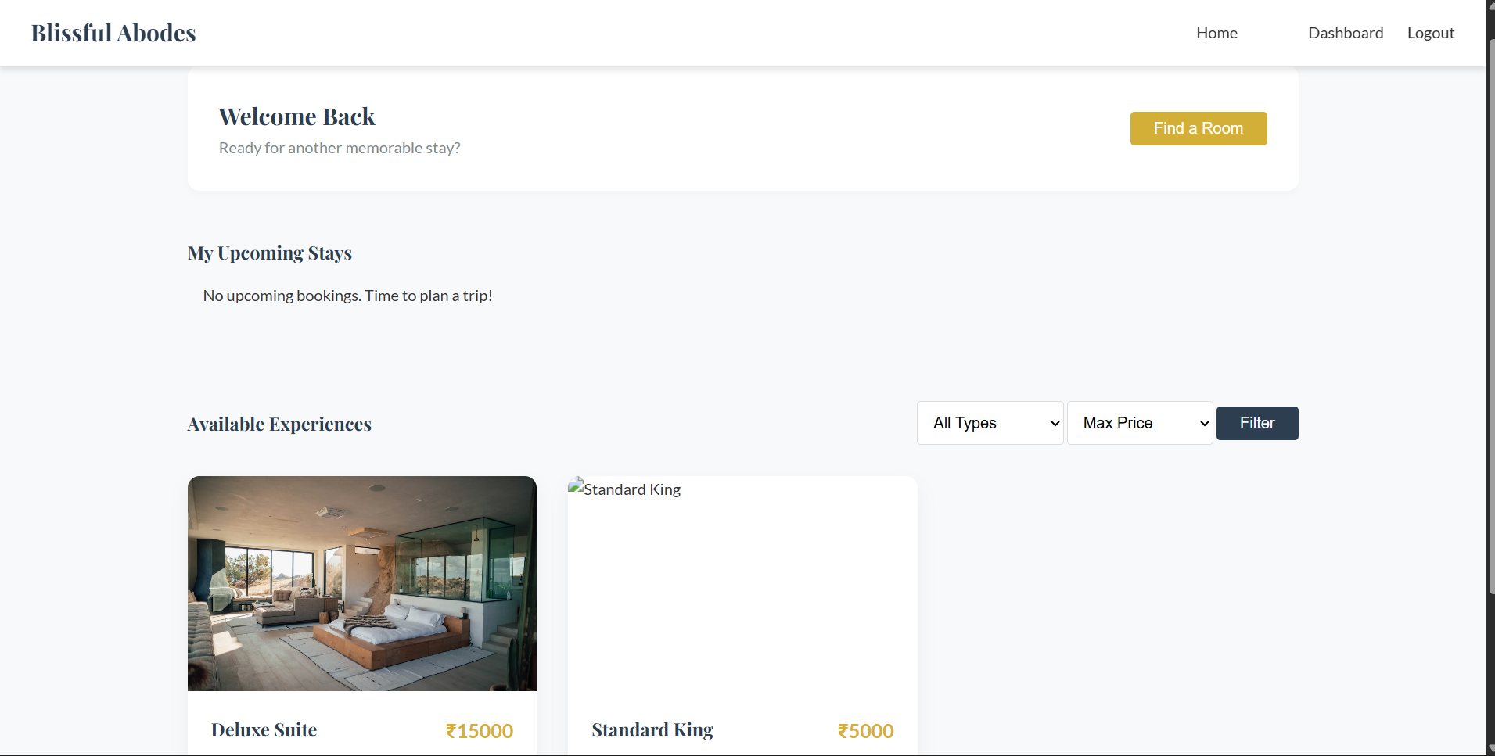

**Conclusion**

The **Blissful Abodes** hotel booking system has been successfully designed and deployed using a reliable, cloud-based architecture. By leveraging core AWS services such as **EC2 for application hosting**, **DynamoDB for efficient data storage**, and **SNS for real-time booking notifications**, the platform delivers a secure, scalable, and user-friendly hotel reservation experience. The system overcomes the limitations of traditional manual booking processes by enabling users to search for available rooms, make reservations, and receive booking confirmations through a single integrated platform.

The cloud-native infrastructure ensures high availability and smooth performance, even during periods of heavy user activity such as peak travel seasons. The integration of the **Flask backend framework** with AWS services enables seamless handling of core operations including user registration and authentication, room availability management, booking processing, and notification delivery. Secure access between services is enforced using **AWS IAM**, ensuring data protection and controlled resource usage.

Extensive testing has validated that all major functionalities function correctly, from user login and room selection to successful booking and notification alerts. The application’s clean interface and responsive design further enhance usability, allowing users to complete bookings efficiently with minimal effort.

In conclusion, **Blissful Abodes** demonstrates how modern cloud technologies can effectively transform the hospitality booking experience. The project highlights the practical application of full-stack development and AWS cloud services to build a scalable, secure, and intuitive hotel booking solution capable of addressing real-world challenges in the hospitality industry.

